

Capstone Project - The Battle of Neighborhoods

Opening a new hospital in one of these two African economic cities (Cotonou and Abidjan)

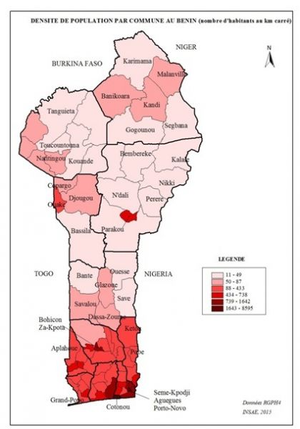

[Cette photo](https://www.populationdata.net/cartes/benin-densite-2013/) par Auteur inconnu est soumise à la licence [CC BY-NC](https://creativecommons.org/licenses/by-nc/3.0/)

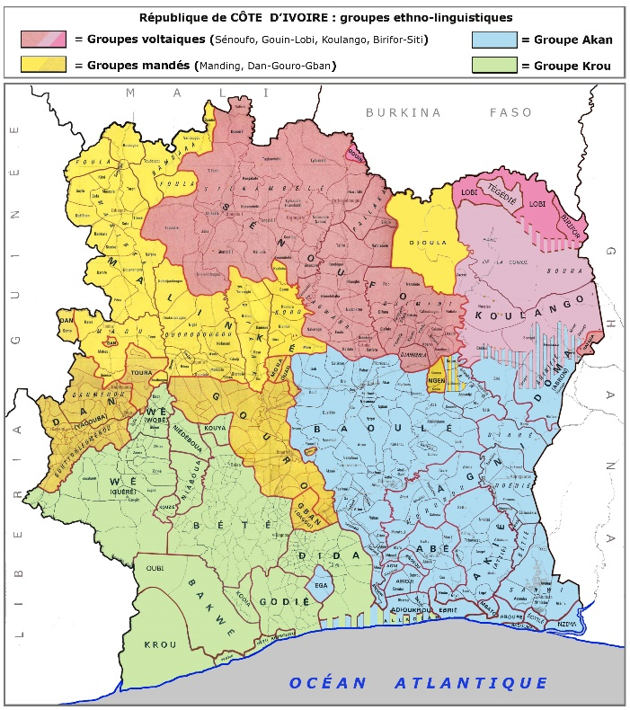

[Cette photo](https://www.populationdata.net/cartes/cote-divoire-ethnies-langues/) par Auteur inconnu est soumise à la licence [CC BY-NC](https://creativecommons.org/licenses/by-nc/3.0/)

1. Introduction/Business Understanding

In this period of Covid-19, many young Africans in the diaspora want to return, invest and do social work in their continent of origin. It is in this context that a young entrepreneur of Ivorian-Benin origin, with the necessary resources, wants to open a hospital in one of these two African economic cities (Abidjan and Cotonou). He can only open one.

First of all, What will be the best place for opening a hospital center in each of these two cities? and which city needs it the most.

* Abidjan

Abidjan is the largest city in Côte d'Ivoire. Former administrative and political capital of the country until 1983, when it was transferred to Yamoussoukro, it is also the most populous city in French-speaking West Africa, and the second largest city and third largest agglomeration within of the Francophonie. Ivorian economic capital, according to the country's authorities, in 2014 it had 4,707,000 inhabitants or 21% of the country's population, while it would represent 60% of the country's gross domestic product. Only Lagos, the former capital of Nigeria exceeds it in number of inhabitants in this region. Considered as the West African cultural crossroads, Abidjan is experiencing strong growth characterized by strong industrialization and rampant urbanization.

Despite the loss of its official status as the capital of Côte d'Ivoire, it remains de facto the seat of most of the country's administrative and national political institutions, and continues to play the leading role in Ivorian political life. (source <https://www.populationdata.net/>).

* Cotonou

is the economic capital and the largest city of Benin. It is a large port city located on the south coast of Benin, West Africa. It has an area of ​​79 km2 and a population of 2,401,067 inhabitants. The slums surrounding the country's largest city, Cotonou, are swelling exponentially. Cotonou is now a large urban area of more than 2.4 million inhabitants, and its population which is growing at a frantic rate (+ 4.8% / year) causes problems of pollution, security, distribution and water purification etc ...

Indeed, the port of Cotonou has greatly increased its activity at the expense of that of Abidjan, which has contributed to the creation of many jobs in the region. But besides this port, economic activity remains dependent on cotton exports, which represent 75% of the country’s income. This monoculture slows down the development of the country, which is struggling to compete with the United States and Europe, which are heavily subsidized in this area.

The diversification of the economy is a necessary step to launch Benin on the path of more sustainable development.(Source : [www.populationdata.net](http://www.populationdata.net))

1. Data

My little experience as a data scientist apprentice has taught me that data sets for locating data banks are not fairly provided (especially for Africa). Indeed even if Fousquare is the database required to carry out this project; geolocation data for Africa is more enriched on Google Maps ... The reason? I don't know yet maybe that the majority of phones in Africa are under Android OS, that we are (African) technologically behind… The answer will be for another time.

The more data we have, the more precise our study will be. We will use the dataset coming from Foursquare as request for the project but we will also use an API (https://outscraper.com/) which will allow us to extract data in json format from Google Maps to compare and deepen the results. of this project. Following this comparison we must extract the data for each Country which will allow us to know, The number of existing hospitals in each city The number and distance of hospitals, and the distance from the district to the city center

We will also use demographic information from the site <https://www.populationdata.net/>

* Librairies

1. Methodology

Nous avons commercé par géolocaliser les villes d’Abidjan et Cotonou, ensuite nous avons collecter les données depuis foursquarre Les hôpitaux et cliniques de chaque ville et leur géolocalisation afficher sur une carte par rapport à leur centre-ville respectif. Apres une

Suite à la mise en visualisation de chacune de ces informations (hôpitaux + leur emplacement) de chacune de ces ville, nous avons comparé les données de Foursquarre a ceux de de Google Maps Places et trouver que Google proposait plus de lieux donc de donnée que Foursquarre.

Nous allons quand meme utiliser le jeux de donnée de Foursquarre et classer les différents type ce centre hospitaliers qu’il y a dans chacune des villes.

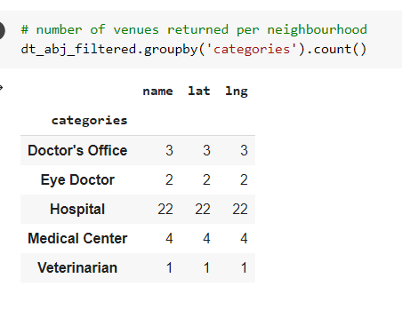

Après la visualisions des clusters :

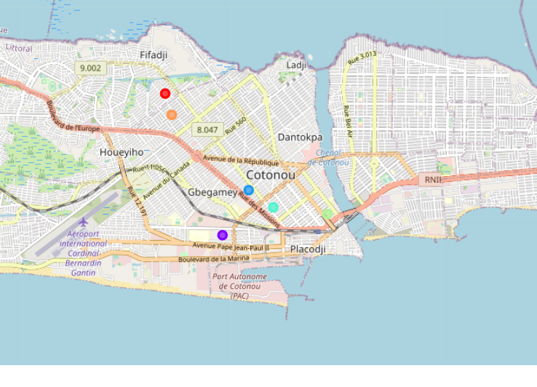

1. RESULTS

The best place to build our Hospital is the area of Kouassi where we have only 1 veterinarian.

The best place to build our Hospital is the area of Boulevard de France.